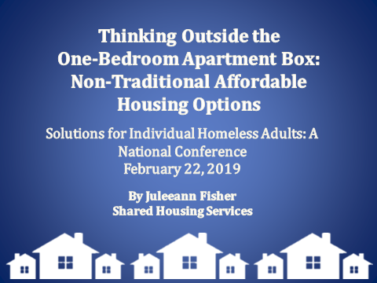
Hello and welcome. My name is Juleeann Fisher and I am with Shared Housing Services in Tacoma, WA. I am the Program Coordinator for the Adult Homesharing Program. Today I am going to be speaking with you about Thinking Outside the One-Bedroom Apartment Box: Non-Traditional Affordable Housing Options.

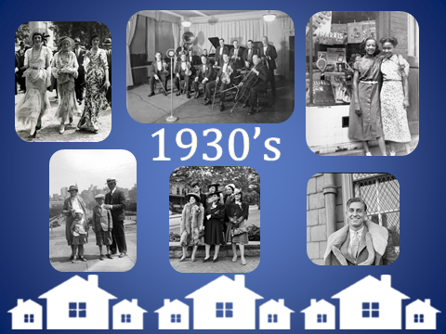

Imagine if you will….The year is 1930. You are in your early 20’s, single, and you work during the week and enjoy seeing a show or going to the dance hall on the weekends. Suddenly the great depression hits. 11,000 banks are failing, leaving you with zero savings. In 1929 unemployment was around 3%. By just 1933 one out of every 4 people are out of work. You are now out of a job and 300,000 businesses are in the process of closing. Hundreds of thousands of families are being evicted from their homes. You might have a little luck with housing because your city is teemed with single-room occupancy houses and hotels (Boarding Houses) cheap rooms to rent. Friends and family are taking in boarders, and some friends are moving in with other family members creating 3 or 4 generations living under one roof. Everyone is doing whatever they can to be housed or to help with housing.

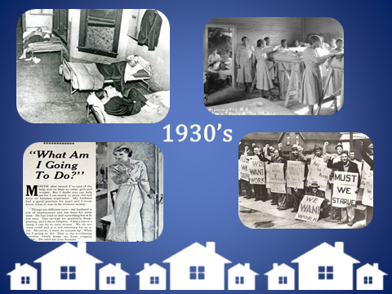

Since WWII American’s views on housing have changed. The new norm isn’t shared space, its privacy. We seem to have experienced a cultural shift in which shared spaces became equated with demoralization and embarrassment. Along with this shift, many older-model housing options, such as the Boarding Houses we saw in the 30’s, have been made illegal through zoning laws that prioritize single-family housing.
So what does this look like today? Similar scenario but now the year is 2019.

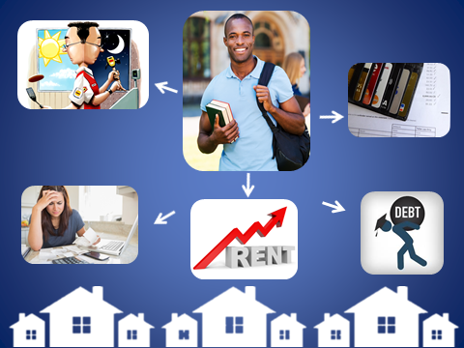

Let’s say, this half of this audience…..You are still in your late 20’s and single. You graduated with your degree and you are working 2 jobs until you can land your dream job just hoping to make ends meet. You have student loans to pay off and credit cards up the wazoo. You have to pay car insurance or else you can’t get to work. In the past two years your rent has gone up almost $300/month, while your income has barely increased, and you are falling behind on your bills. You can’t get into a cheaper apartment because 1…they really no longer exist & 2 you need good credit, & 3 you need to make 3x the rent to qualify.
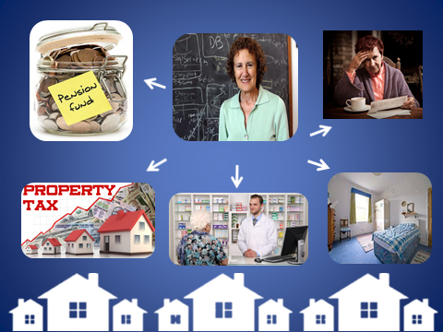

Now the other half of the audience …..you are in your mid 70’s. You’re a retired teacher living on a fixed income. You own your home but you live month-to-month. Your property taxes have increased again this year and your doctor has put you on three new prescriptions that your insurance doesn’t cover. It is getting harder to complete household tasks or to maintain your home on your own. You are torn between buying your medication and keeping the heat on. You have lived in your home your entire adult life and the 2 rooms where your kids grew up are sitting vacant.
Those of you in your 20’s are still working, but your property manager has informed you of yet another increase in rent. You are one unexpected expense away from being homeless and not sure how you are going to buy groceries this month.

On the other side we have the seniors who are going to lose their home if they choose to buy their prescriptions or possibly damage their health if they choose to keep their home.

The senior’s neighbor happens to know the young person losing their housing, and suggests to the senior that they rent out their spare bedroom to this person for a reasonable rate to earn extra income while also helping the young person out who is struggling to currently get by. Older adults and disabled persons are already at risk and vulnerable without having to worry about stable housing. Without stable housing their chances of thriving decrease tenfold. These older adults are often house rich and cash poor, and utilizing their spare room gives them the extra income they need to thrive.
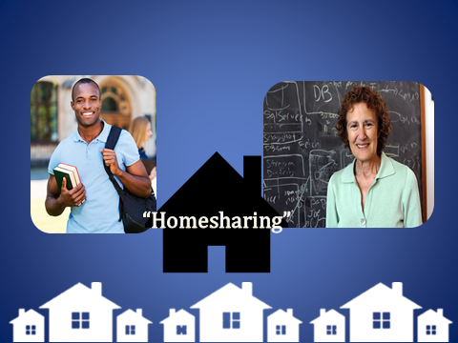

In this case, the younger person moves in, works hard at their 2 jobs to pay off a good chunk of their student loans and lands a great job. The senior is able to keep their home and purchase their new medications. Both parties have now benefited from home sharing using existing housing.

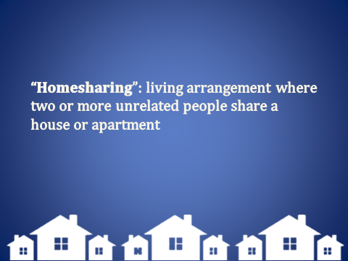
Home sharing is a living arrangement in which two or more unrelated people share a house or apartment. Home sharing is an increasingly important component in the quest to use existing housing stock more effectively and create more affordable room rental options.
Home sharing is a decades old solution that is meeting the rising need for affordable housing. People are slowly rediscovering shared housing across the nation and reaping its rewards. As of just 2 years ago, 20% of Americans were living with older relatives (more than at any time since 1950). This concept is so important when you consider that by 2020 the number of older adults experiencing homelessness is set to increase by 33%.
Now let’s take a look at this scenario without the help of shared housing.
Members of the audience in your 20’s….you can’t keep your apartment because of the rent increase and begin sleeping in your car. You end up losing one of your jobs because of not being able to get to work on time. You fall deeper in debt and find yourself spending more money on fast food and motels for snowy nights.
Thankfully you are able to get into a Rapid Rehousing program which allows you to stabilize and get back on your feet.
And you seniors did your best to balance home bills with medical bills but it became overwhelming and unfortunately you lost your home. You are now homeless. Statistically speaking, what we have done here is traded one person experiencing homelessness for another person entering into homelessness. We also used up a space in a housing program while having a beautiful home become empty.

Had we stepped in and introduced home sharing we would have two people stably housed, a home saved and a decrease in the homelessness population. It is a win-win situation!

Let me try to explain this with a demonstration….
Imagine this large container in the middle is full of people who are currently experiencing homelessness and in need of affordable housing. This container here is full of our most vulnerable population, seniors on fixed incomes, disabled persons, the working poor, and even students. The last container is full of people who are housed. This demonstration is to show you how “Homesharing” is helping the big picture and why we are having success in lessening the homeless pool here in the middle. Ending homelessness will not only require a focus on adult individual’s currently experiencing homelessness but also a focus on preventing people from becoming homeless. On average two out of three people experiencing homelessness are single adults. Cities have made headway in addressing homelessness using housing first models, permanent supportive housing and rapid rehousing. For every homeless individual we find housing for we lessen the pool of people experiencing homelessness and increase the number of people housed. As you can see providing housing programs are having the desired effect….but we have forgotten about the vulnerable populations over here (points to senior audience section). As we have been focusing on getting these already homeless individuals housed, these seniors have lost their homes and are now spilling over into the container of persons experiencing homelessness, virtually undoing all of the work we just did. Once again we have traded one homeless situation for another, but with the Shared Housing model we could be pulling from both the vulnerable population pool and the currently homeless pool and filling the housed pool. We are helping someone who is possibly at risk and helping someone in need of a place to call home, thus creating a mutually beneficial Homesharing relationship: maintaining housing and obtaining housing.

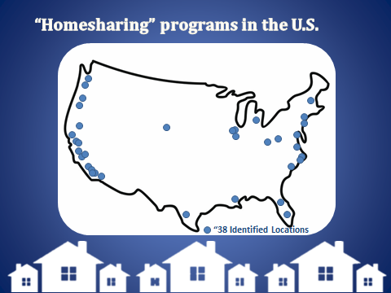
Currently there are around 60 home sharing programs up and running around the country, I have identified 32 on the map pictured. 60…..just let that sink in. That’s 1.2 programs PER STATE. Housing sustainability relies on communities with affordable housing options and the effects of a lack of such housing are being felt all over the US. For every $100 increase in rent in a region, researchers estimate a corresponding 15% increase in the prevalence of homelessness. Housing affordability impacts the quality of life in our communities. This is where Shared Housing is beneficial not only to the parties involved, but to the community itself.
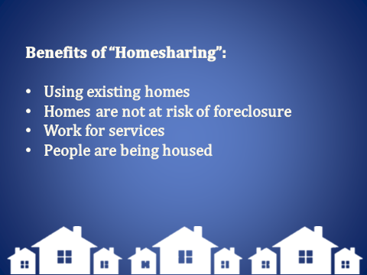
Shared Housing uses existing housing inventory lowering the need to raise taxes to build more affordable housing. Neighborhoods are being strengthened and maintained by fewer foreclosures or turnover of homes. Affordable housing options are created for people experiencing homelessness or unstable housing.

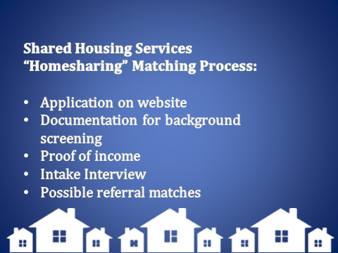
The Adult Homesharing program with Shared Housing Services has been operating for 27 years. Each potential client is identified as either a “Home Seeker” a person needing affordable housing or as a “Home Provider” a person or persons looking to rent a room(s) out in exchange for services and/or rent. They start the process by completing a thorough application online. After the application is completed then a multi-state background check is conducted. Once a potential client’s background check results come back we schedule an intake/interview appointment. “Home Seekers” are interviewed at our office and “Home Providers” are interviewed in their homes and a home inspection is conducted. Matches are criteria based, so it is our goal to understand each client’s need and wants to properly make a referral for a successful “Homesharing” arrangement
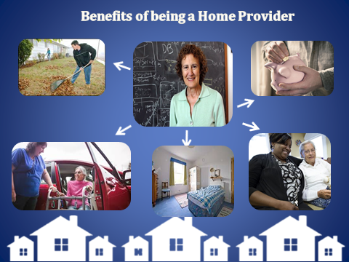
People choose to be Home Providers for a multitude of reasons. One example is the scenario we have been discussing. A senior is experiencing difficulties keeping up with household expenses and medical bills. This senior will benefit from the added income of having a housemate. Plus a senior’s physical/mental health benefits from having someone else in the home. Many seniors experience loneliness and depression when they are alone and confined to their homes. A University of California, San Francisco (UCSF) study found that participants 60 years of age older who reported feeling lonely saw a 45 percent increase in their risk of death. Isolated survey respondents also had a 59 percent greater risk of mental and physical decline than their more social counterparts. This decline manifested specifically in participants’ abilities to perform activities of daily living. In other words, loneliness and isolationism have the potential to accelerate a senior’s need for assistance from a family caregiver or another source of long-term care. Some Home Providers choose to share their home for just this reason….to combat loneliness and isolationism and have companionship.
Another reason for home sharing is because they need a “Home Seeker” to assist them with household tasks and/or transportation because they are no able to complete these tasks or able to drive. Arrangements can be made for a reduced rent for the Home Seeker in exchange for services and assistance in the home. This type of arrangement allow for seniors on a fixed income to use their spare room to receive needed services while providing very affordable housing to those home seekers who need it.
Some people become Home Providers for the simple fact that they want to help someone get to a place where they are stable and eventually able to move out on their own. And although I am using seniors as an example today, let’s not forget about the single parents who could use the extra income or maybe the help of an older home seeker to help with their children. Or the disabled 30-something year old on a fixed income whose needs help to live independently or whose rent went up and they now need to home share to make extra income. Or even the younger renter who needs a person to share his apartment with to make ends meets. Whatever the reason for Homesharing, we are seeing the positive impacts that home sharing has on individuals, vulnerable community members, and our community as a whole.

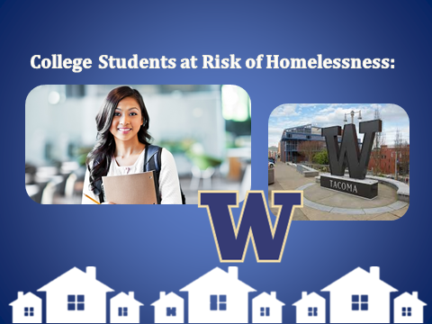

Now there is one population that we have not touched on, and that is college students. In a 2017 survey of 33,000 community college students funded by The Kresge Foundation’s Educational and Human Services programs, 33% of community college students were hungry, nearly 50% lacked secure housing and 14% reported being homeless.

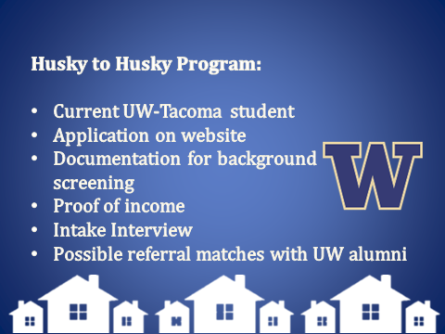
At The University of Washington Tacoma campus we have seen this trend. At the beginning of the 2018 fall semester 17 students identified as being homeless. Shared Housing Services as well as Student advocates were concerned with this number. Conversations began and ideas started flowing and the Husky to Husky Program was created. We have partnered with University of Washington Tacoma and their Office of Student Advocacy and Support to assist in housing students experiencing homelessness or insecure housing. What makes this program unique is that we are reaching out to faculty, staff, and Alumni to be Home Providers for students who are currently enrolled in classes at UWT.
We are also working with local veteran agencies on the possibility of creating a pilot program to help veterans’ currently experiencing homelessness. The Vet2Vet program would focus on recruiting older veterans who have a spare bedroom to become home providers for veterans needing an affordable place to call home. We feel a Vet2Vet home sharing arrangement could have huge benefits for both populations.
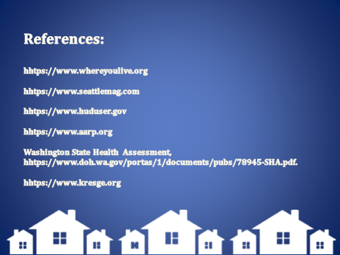
Partnering with other agencies in our community helps make us stronger and reach more people. Together we can connect people and foster independence through innovative and affordable housing, because everyone needs a place to call home.

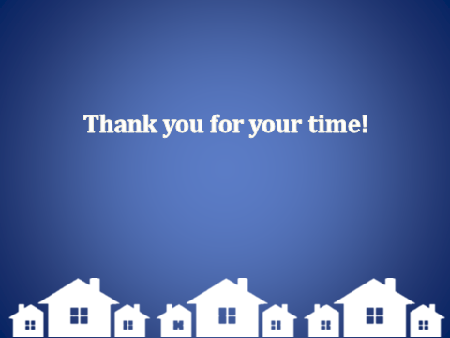
Thank you.

